CSS Basics

- What is CSS?
CSS = Cascading Style Sheets
Controls layout, colors, fonts, spacing
Separates design from content

- VS code setup tools
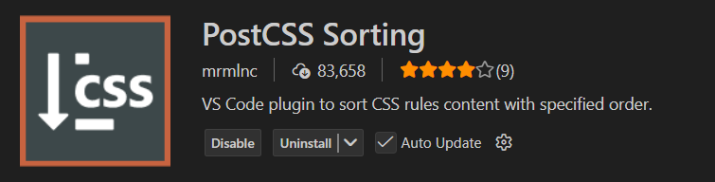
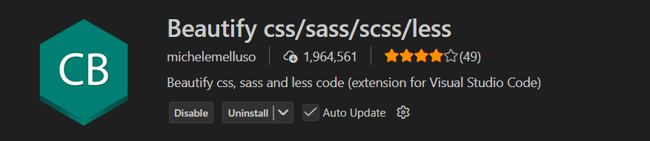

CSS Syntax
Selector {
property: value;
}

Types of CSS
- Inline CSS
- Internal CSS
- External CSS //Best practice

- CSS selectors
  - Simple selectors (select elements based on name, id, class)
p {
font-weight: bold;
}
  - Combinator selectors (select elements based on a specific relationship between them)
h2 .text {
color: red;
}
  - Pseudo-class selectors (select elements based on a certain state)
Button:hover {
Opacity: 0.7;
}
  - Pseudo-elements selectors (select and style a part of an element)
p::first-letter {
font-size: 200%;
}
  - Attribute selectors (select elements based on an attribute or attribute value)
a[‘target=”_blank:] {
Background: red;
}

- Fonts & Units
px - fixed size ( eg. 16px)
% - Relative ( eg. 50% )
em - Relative to parent ( 1.5em )
rem - Relative to root ( 1rem )
vw - Viewport width ( 50vw )
Vh - Viewport height ( 50vh )

- CSS Backgrounds
  - background-color
  - background-image
  - background-repeat
  - background-attachment
  - background-position
  - background (shorthand property)

- CSS borders
Border: thick style color;
Eg . p {
Border: 1px solid red;
}

- CSS fonts Family
- Using CDN links
https://fonts.google.com/

- Use custom fonts
@font-face {
font-family: myFont; /* set name */
src: url(sansation_light.woff); /* url of the font */
}

p {
font-family: myFont; /* use font */
}

* chrome browser extension
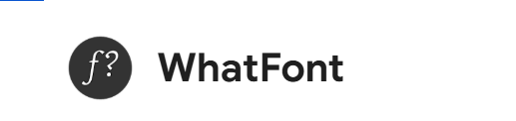

- CSS Box Models

Box Model Components
- Content
- Padding
- Border
- Margin

Diagram Concept
Margin
└ Border
└ Padding
└ Content

box-sizing

* {
box-sizing: border-box;
}

- Prevents layout breaking
- Recommended default

@charset "UTF-8";

* {
padding: 0;
margin: 0;
box-sizing: border-box;
}

